# IAMCR 20**22** Pre-conference events at Xi’an Jiaotong-Liverpool University, Suzhou

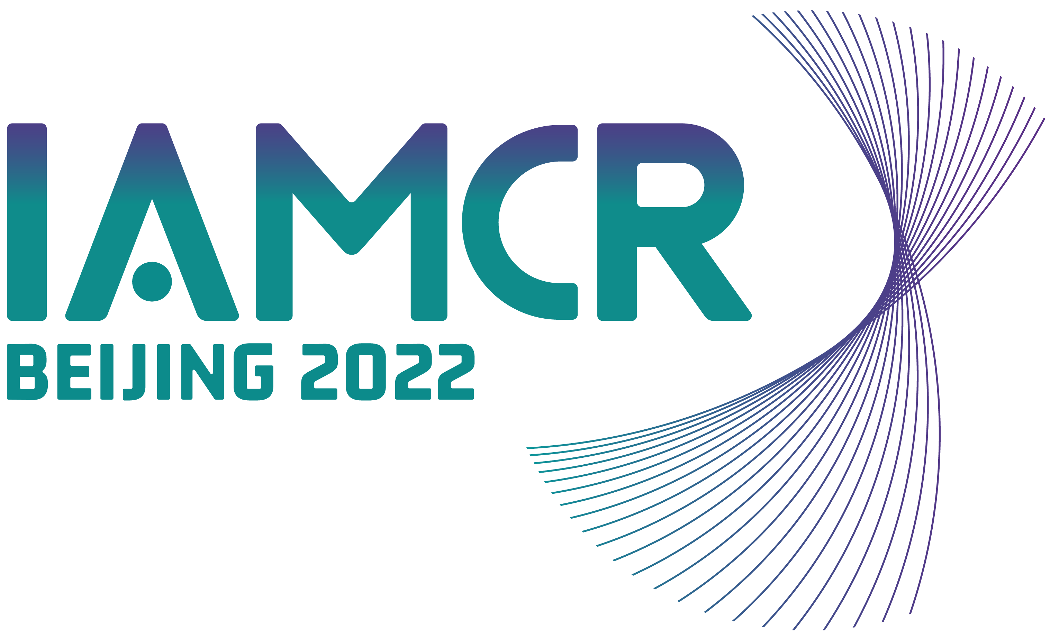IAMCR 2022 will be on an online conference with a national hub at Tsinghua University in Beijing. The hub will enable Chinese scholars, and others able to be in Beijing, the opportunity to participate in live plenaries and other sessions and events streamed to remote participants around the world.

In a similar fashion, IAMCR 2022 offers the possibility for “hybrid” pre-conferences. These will be held at Xi’an Jiaotong-Liverpool University (XJTLU) in Suzhou. XJTLU will provide meeting rooms for local participants, streaming facilities for remote participants, and interactive channels linking local and remote. **Pre-conferences can be held on 8, 9 and/or 10 July 2022**.

The Suzhou Pre-conference Organizing Committee invites media and communication researchers to consider submitting proposals for hybrid pre-conferences. Hybrid pre-conferences at XJTLU can be organised by individual or institutional IAMCR members alone or in partnership with others. Approved events will be featured on the IAMCR 2022 website, social media and newsletters.

XJTLU will also fund 50 grants of up to 2,500 CNY to pre-conference participants to mitigate the cost of travel between Suzhou and the main conference hub in Beijing, plus local travel and accommodation costs. Grants will be awarded to students and early-career scholars who are IAMCR members. More information and applications for these grants will be available in March 2022.

The XJTLU hybrid model will be especially interesting for pre-conference organisers who expect or would like to have significant participation from China and especially those who would like to organise their conference with a partner in China. If you would like to do this but do not have a partner in China, XJTLU may be able to help you identify and connect with one.

Pre-conferences can also be organised independently of XJTLU in either online, face-to-face or hybrid modes.

Whichever modality or location is desired, pre-conference event organisers should submit a formal application. Applications must be received no later than 9 February 2022, but we strongly recommend that you send them earlier. Decisions will be made on a rolling basis, generally 2 to 3 weeks after an application is submitted.

There are limited opportunities for pre-conference events at XJTLU, Suzhou. For questions, contact Xiaoling Zhang at [Xiaoling.Zhang@xjtlu.edu.cn](mailto:Xiaoling.Zhang@xjtlu.edu.cn).

Email your completed application form to Bruce Girard at [bgirard@iamcr.org](mailto:bgirard@iamcr.org)

## 1. About your pre-conference event

### Applicant details:

Provide details of the main applicant and any partners. Include the contact details of the main contact person or persons and indicate those who are IAMCR members either individually or through their institutions.

### Title of the event:

### Description of the event:

Provide a maximum 500 word description of the pre-conference event. You may also attach documents such as a call for proposals or provide URLs. Include, for example, information about the agenda, speakers, participants, and outcomes.

### Date and time (pre-conferences at XJTLU **can be held on 8, 9 and/or 10 July during normal business hours local time (UTC +8)**:

### Location and modality:

Let us know if your event will be a hybrid conference at XJTLU, or an online, face-to-face or hybrid event at a different location.

### Estimated number of local participants:

### Estimated number of remote (online) participants:

### Organisers and sponsors:

Provide information about the key organisers and sponsors (individuals and/or institutions).

## 2. Web information

If your event is approved, the information you provide below will be included on the IAMCR 2022 website.

### Full title of your event:

### Short title (if any):

### Short description:

(maximum 200 words)

### Location and modality:

### Date and time:

### Participation and registration:

(How can people participate? Is registration required? Cost?)

### Will the event have its own website?

Is so, provide the URL

### Convenor(s):

* + 1. Brief description of institution(s) or individual(s)

### Organiser(s):

Name and affiliation of principal organiser(s)

### Public contact email:

### Public contact telephone number (if applicable):

Send the complete CfP and any other relevant documentation you want to appear on the website.

Send any images that we can use in our promotion of the pre-conference (logos, photos).

## 3. Role and visibility of IAMCR

Will the IAMCR and IAMCR 2022 logos and URLs be displayed on the event website and/or other promotional materials such as posters, flyers and promotional emails?

Will this short text describing IAMCR be included on the event website and /or other promotional materials? *"The International Association for Media and Communication Research - IAMCR - is the preeminent worldwide professional organisation in the field of media and communication research"*.

Will IAMCR be recognised as a co-sponsor at the event's opening and/or closing sessions?

Will an IAMCR representative be asked to speak during the event?

Will IAMCR be invited to organise a panel or other intervention during the event?

If any publications, videos, etc. are produced as a direct result of the event, will IAMCR's logo, URL, and descriptive text be included?

Will you prepare a short article (300-500 words) for publication on IAMCR's website after the event?

Will a final report of the event be produced? If so, can it be published in whole or in part on IAMCR's website?